Lam Tai Fai College
林大輝中學

Election of Alumni Manager 校友校董選舉
Ballot Paper選票

Vote Counting Time: 2:30pm, 16th January 2016
點票時間﹕ 2016年1月16 日下午2時半

Please read carefully the “Directions for Voting” overleaf before casting vote.
填寫選票前請細閱背頁的「投票人須知」

Please use a blue or black ball-point pen to mark a “✓” in the box against the number of the candidates you vote for. The number of “✓” you marked on the ballot paper should not be more than ONE. Otherwise, your ballot paper will be considered null and void.

請用藍色或黑色原子筆在選票上候選人編號旁的空格內加上「✓」號。你在選票上所填的「✓」號，不能超過一個，否則，選票便會作廢。

Candidates 候選人

 1. 郭灝霆 Mr. Kwok Ho Ting Marco

 2. 王皓炘 Mr. Wong Ho Yan Jimmy

 3. 馮穎祺 Miss Fung Wing Ki

 4. 吳芷晴 Miss Ng Chi Ching

投票人中文姓名： _______________________ 離校年份：___________________

Lam Tai Fai College
Election for Alumni Manager

Directions for Voting

- Put no other marks on the ballot paper other than the mark “✓” or it will be considered null and void.
- Return the ballot paper to the school’s General Office through one of the following methods before 5:00pm, 3rd January, 2016.

- submit to the school’s General Office in person OR
- e-mail to alumni@ltfc.edu.hk OR
- fax to the school’s General Office at 2786 9617 OR
- mail by the stamped self-addressed envelope attached to the school

林大輝中學
校友校董選舉

投票人須知

- 除「✓」號外，請勿在選票上劃上其他記號，否則選票便會作廢。
- 將填妥之選票放入投票信封並封妥。於2016年1月3日下午5時正前，逕由以下其中一種方法將選票交回校友會：
  - 親身交往本校地下校務處 或
  - 電郵至 alumni@ltfc.edu.hk 或
  - 傳真至本校校務處，傳真號碼為2786 9617

Examples of Void Ballots 廢票例子：
(1) Wrong Mark (e.g. “✗”)  寫上錯誤記號 (如: 「✗」)  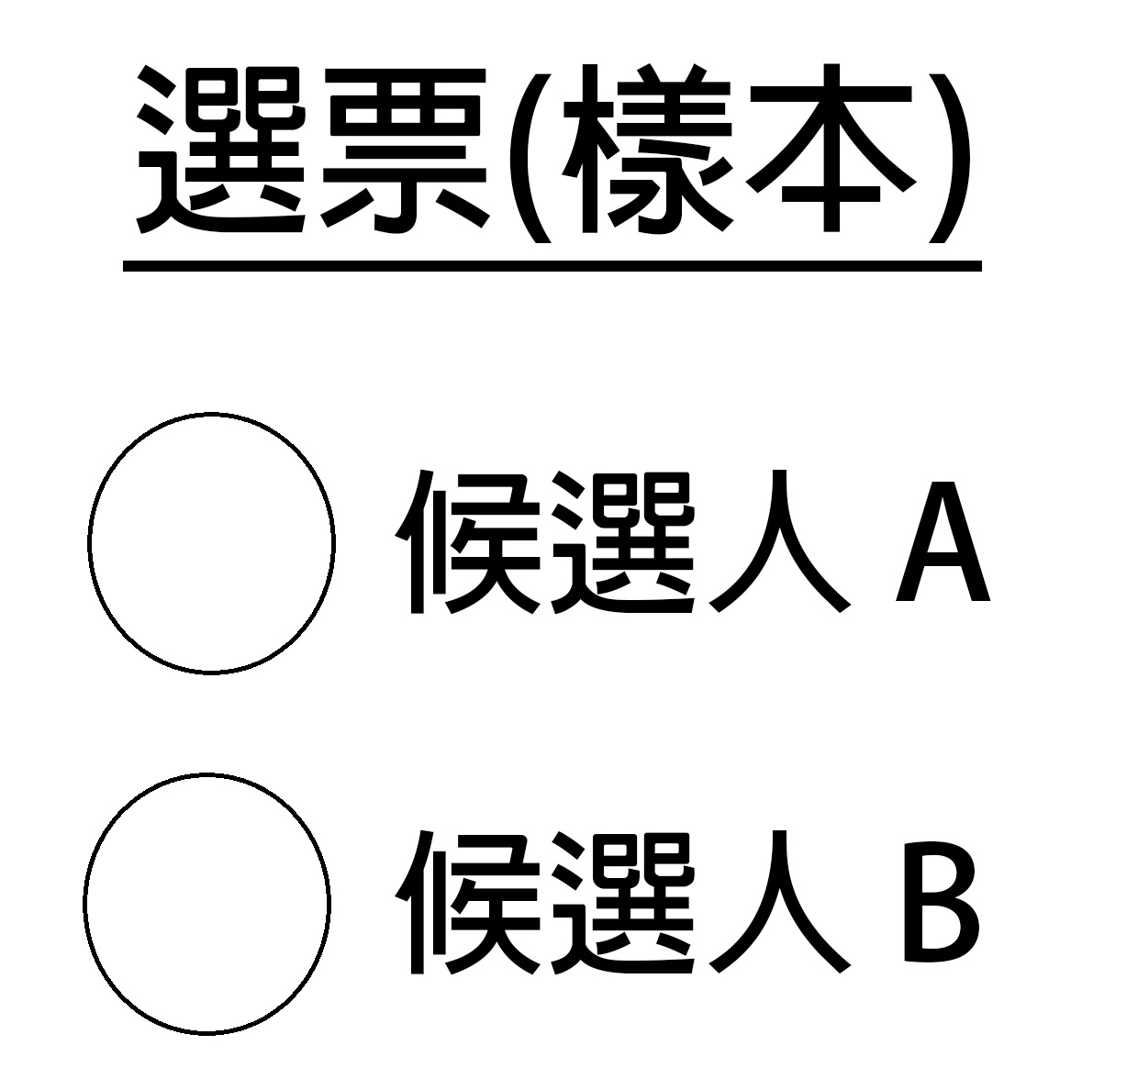  ✗  / | (2) Marking “✓” outside the box  在方格外加上「✓」號  ✓  ✓ | (3) Spoiling ballot papers  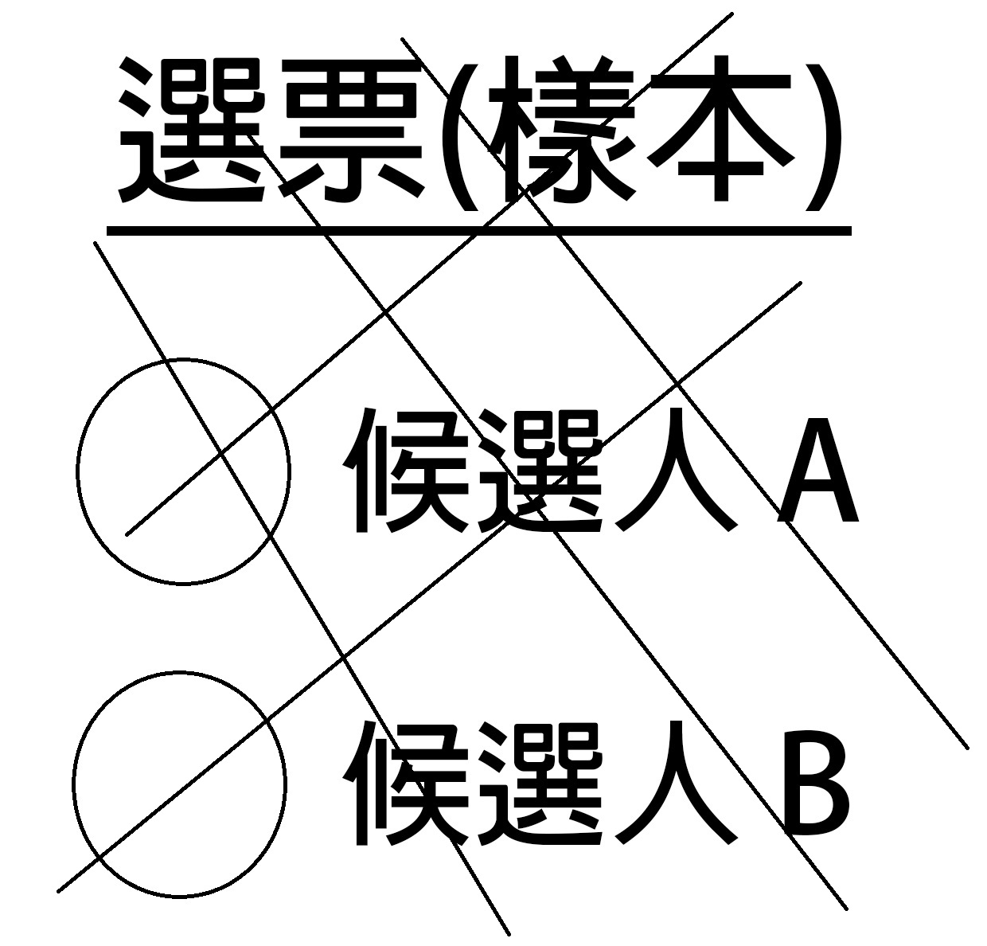  塗污選票  